NEWS RELEASE

FOR IMMEDIATE RELEASE

Rutgers Division of Continuing Studies Teams Up To Donate To A Disabled Mother Of Three

New Brunswick, New Jersey, December 14, 2017—For some people, the fact that they have a roof over their head may go unnoticed this holiday season, but for others it is a lot to be thankful for. This year, employees from two units at the Rutgers Division of Continuing Studies—the Office of Summer and Winter Sessions and the IT department—helped one family from Perth Amboy get back on their feet after a series of unfortunate events resulted in a ten-month period of homelessness.

The family recently moved into a new place after living in a homeless shelter for almost a year. According to the disabled mother of three young children, “I’m getting by with child support while I apply for disability benefits.”

To help the family get back on the road to recovery, the Rutgers employees teamed up to donate over $1000 worth of food, clothing, personal hygiene products, and other items, through the Rutgers Against Hunger (RAH) Adopt-A-Family Program.

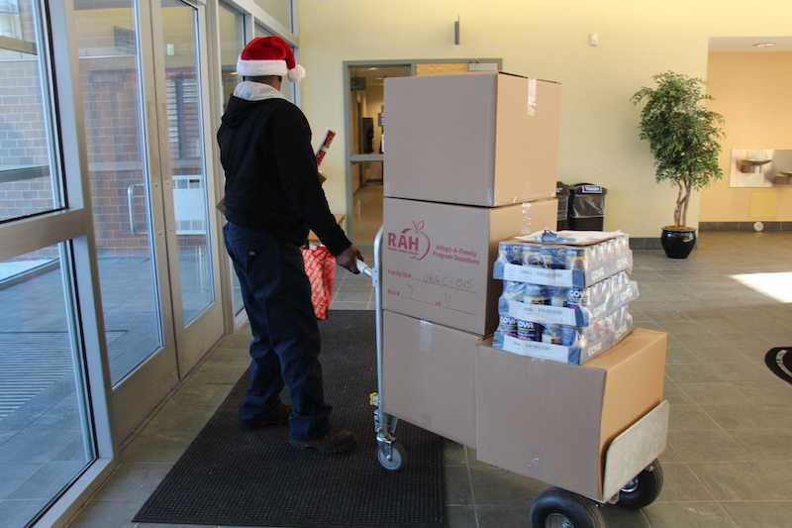
Food, clothing, personal hygiene products, and other items, donated by Rutgers Division of Continuing Studies employees, are being carted off to a needy family of four. Photo Credit: Mariah Pierce
“Although the mother didn’t ask for anything on her list, we wanted to be sure that she received something for herself. So, as a surprise, we each donated money to purchase a gift card just for her,” says Barbara Rusen, Assistant Director for the Rutgers University–New Brunswick Office of Summer and Winter Sessions. “In addition, I reached out to our Division’s IT department to see if they had a used laptop they could donate so the kids won’t need to reserve library resources to complete their homework projects.” Instead of a used laptop, IT@CS Director, Warren Nevins, provided a brand new laptop that his group contributed money towards to purchase on their own.

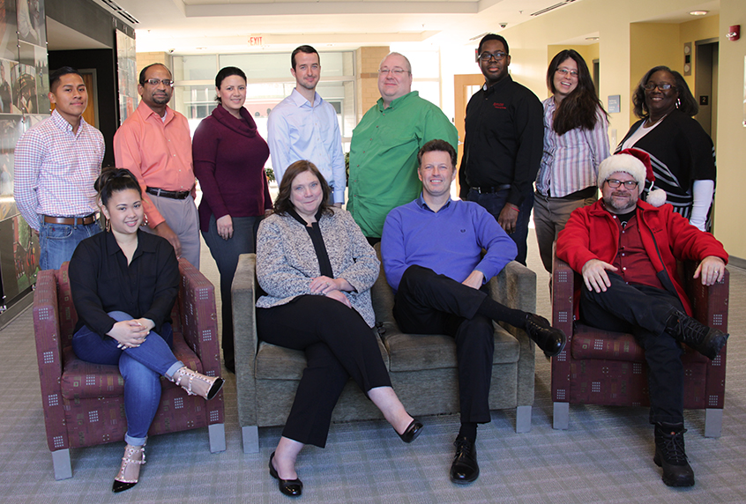
The Rutgers Division of Continuing Studies IT department contributed personal funds toward a laptop for the disabled mother’s three children. Photo Credit: Mariah Pierce
Because the six-year-old son indicated on his wish list that he loves to swim, Office of Summer and Winter Sessions’ Program Coordinator Jen Charnecky also reached out to the local YMCA to donate a membership to the family.

According to Charnecky, “we are very fortunate to not have to suffer from the same hardships as they do. So, our hope is that a little team effort goes a long way for the family this holiday season.”

To find out how you can get involved, visit rah.rutgers.edu.

###

