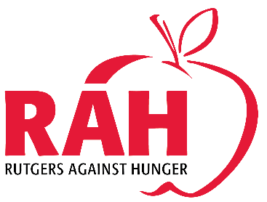

Rutgers Against Hunger’s 2017 Adopt-A-Family Summary
Rutgers Against Hunger is pleased to announce that another year of the Adopt-A-Family initiative has successfully concluded! We want to extend our sincerest gratitude to everyone involved. With your help, we were on par with our goal of sponsoring 250 families!
Adopt-A-Family began in 2009 and served as a way for Rutgers departments and individuals to support local families living near our New Brunswick and Newark campuses. The program has grown exponentially since its inception. We are thrilled to announce that 2017 has been yet another successful season: for perhaps the first time, we had more sponsors sign up to help than we had families to assign.
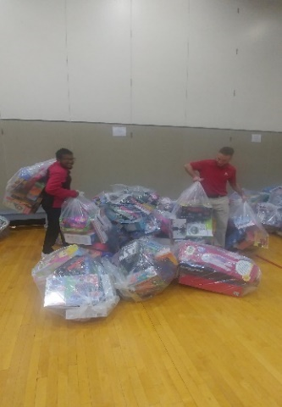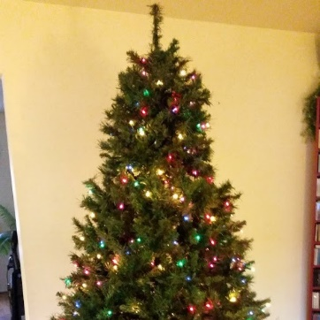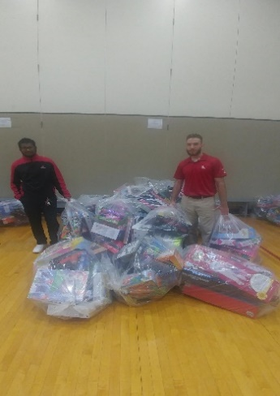
A Christmas tree donation from RU Facilities & Picking up our generous allotment of toys from The Big Chill 5K
Over the past few years, we have established partnerships with many different social services agencies who refer to us their most in-need families. These New Brunswick-area agencies included: Five Loaves Food Pantry, Greater Brunswick Charter School, Lord Stirling Community School, University Behavioral Health Center, Rutgers Price Family Fellows, Tiny Tots Academy, Paul Robeson School, Roosevelt School, School Based Youth Services Program, Coordinated Family Care, Multicultural Community Services, Center for Great Expectations Adult and Adolescent Programming, Permanent Supportive Housing, and Outpatient Programming. Agencies from Adopt-A-Family Newark included: Marion P. Thomas Charter School- Select Elementary Academy, YMCA of Newark and Greater Newark, and Academy Street Fire House.

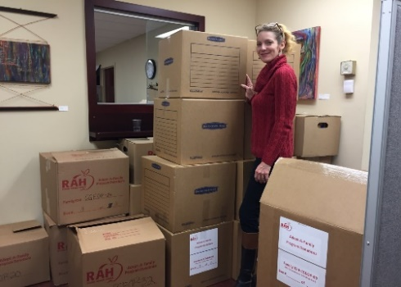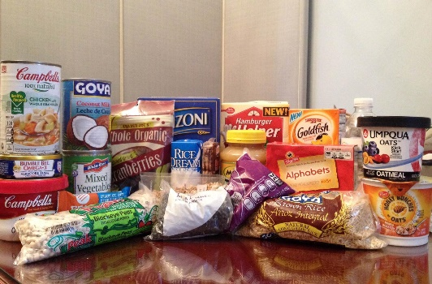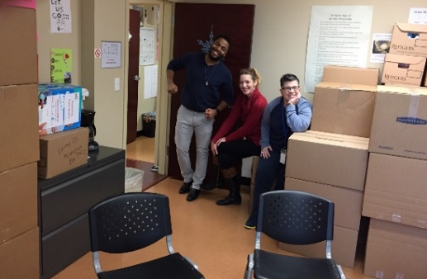
Team Members at The Center for Great Expectations-Outpatient Facility in New Brunswick & AAF Food Donations
Each participating agency provides us with information on their referred families; our generous sponsors then purchase items for those families based on their specific needs. Providing food is our first priority, however our sponsors go above and beyond the basics, often purchasing clothing, toys, toiletries, and other gifts for their adopted families. The gifts are then packed in RAH boxes and picked up by a wonderful team from our University Facilities Department during the month of December.
During this time, we designate each delivery day to one or two agencies. The packages are picked up throughout Rutgers in the morning and delivered to their respective agencies in the afternoon. It is absolutely heartwarming to see how this brightens the spirits of those receiving the packages. Smiles are wide and happy tears are often shed. We wish there were a better way to convey to you what a difference your generosity has made in these families’ lives.
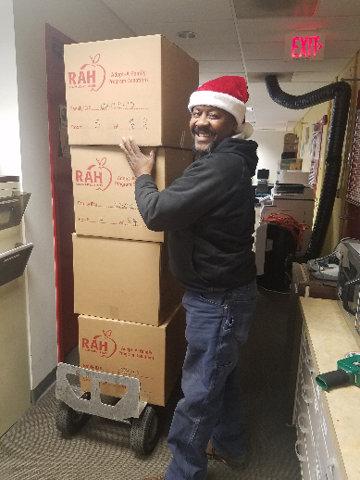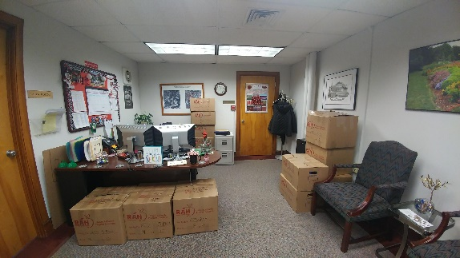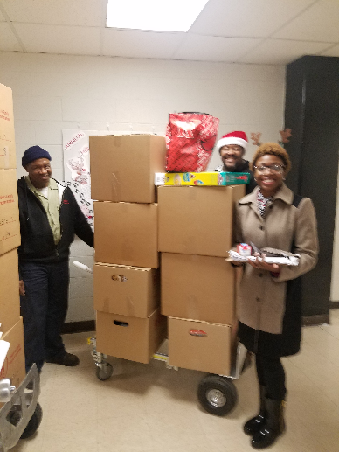
Crew Members & Gift Donation Boxes at The Dean’s Office in Martin Hall
To date, Adopt-A-Family has provided food and gifts to over 1,913 families. Again, we thank everyone who took part in Adopt-A-Family this year including our generous sponsors and donors, our hardworking facilities team, and our volunteers who helped spread the holiday spirit to all partnering agencies.
We hope you all have an awesome spring semester!
Sincerely,
Tiffany Gathright, Lauren Errickson, and Dr. Larry Katz
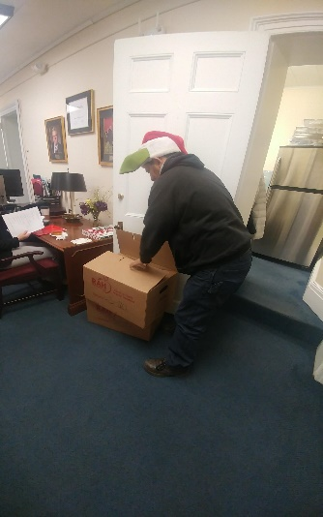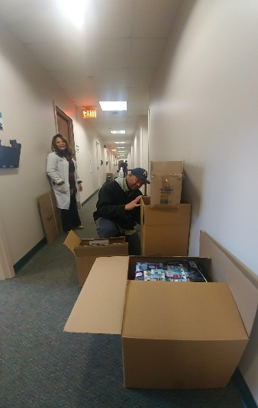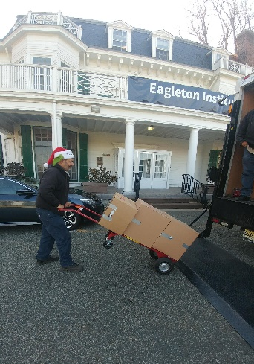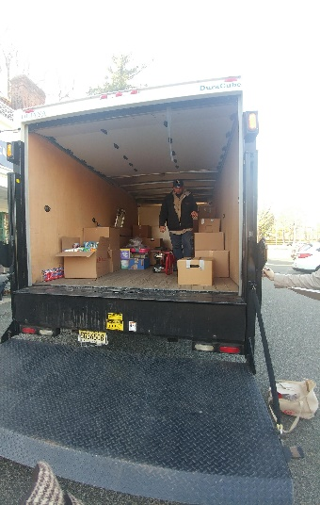
Packing up & loading up at the Robert Wood Johnson Medical School and Eagleton Institute of Politics

!

